**Pizza sales SQL queries**

1. **KPI’S**

1.**Total Revenue:**

select sum(total_price) as total_revenue from pizza_sales

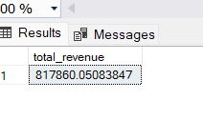

2.**total average value:**

Select sum(total_price)/count(distinct(order_id)) as avg_order_value from pizza_sales

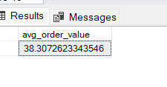

3.**T**otal pizza sold:

Select sum(quantity) as total pizzas sold as total pizza sold as pizza_sales

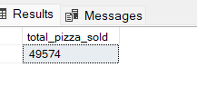

4.**total orders:**

select count(distinct(order_id)) as total_orders from pizza_sales

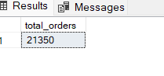

5.**Average pizza per order:**

select cast(cast(sum(quantity) as decimal(10,2)) /

cast(count(distinct(order_id)) as decimal(10,2)) as decimal(10,2)) as avg_pizza_per_order from [dbo].[pizza_sales]

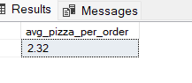

**B.Daily trend for total orders:**

select DATENAME(DW, order_date) as order_day, count(distinct(order_id)) as total_orders from pizza_sales group by

DATENAME(DW,order_date)

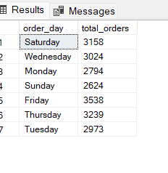

**C . Monthly trend for orders:**

select DATENAME(month,order_date) as month_name ,count(distinct(order_id)) as total_orders from pizza_sales group by

DATENAME(month,order_date)

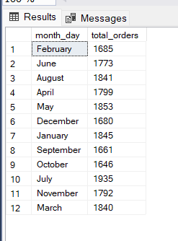

**D.%of sales by pizza category:**

select pizza_category, cast(sum(total_price) as decimal(10,2)) as total_revenue , cast(sum(total_price) as decimal(10,2)) *100/(select sum (total_price) from pizza_sales) as pct

from pizza_sales group by pizza_category

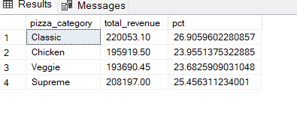

Here we can also add where clause to filter particular results

**E.%of sales by pizza size:**

select pizza_size, sum(total_price) as total_sales, sum(total_price) *100/(select sum(total_price) from pizza_sales ) as percentage_of_sales from pizza_sales

group by pizza_size

order by pizza_size

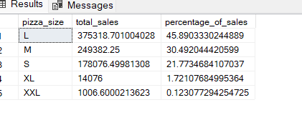

**F.Total pizza sold by pizza category:**

select pizza_category,sum(quantity) as total_quantity_sold from pizza_sales

group by pizza_category

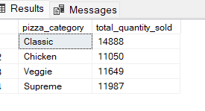

**G.Top 5 pizza by revenue:**

select top 5 pizza_name,sum(total_price)as total_revenue from pizza_sales

group by pizza_name

order by total_revenue desc

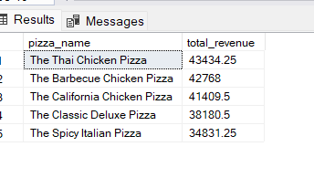

**H.Bottom 5 pizza by revenue:**

select top 5 pizza_name,sum(total_price)as total_revenue from pizza_sales

group by pizza_name

order by total_revenue asc

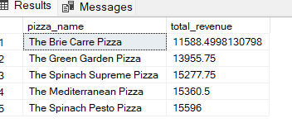

**I.Top 5 pizza by Quantity:**

select top 5 pizza_name,sum(quantity) as total_pizza_sold from pizza_sales

group by pizza_name

order by total_pizza_sold desc

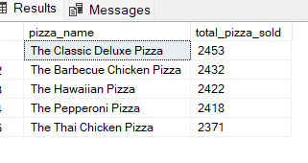

**J.Bottom 5 pizza by Quantity:**

select top 5 pizza_name ,sum(quantity) as total_pizza_sold from pizza_sales

group by pizza_name

order by total_pizza_sold asc

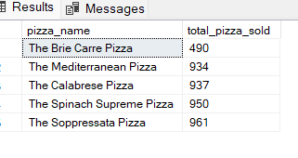

**K.Top 5 pizza by total orders:**

select top 5 pizza_name,count(distinct(order_id)) as total_orders from pizza_sales

group by pizza_name

order by total_orders desc

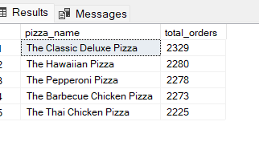

**L.Bottom 5 pizzas by total orders:**

select top 5 pizza_name,count(distinct(order_id)) as total_orders from pizza_sales

group by pizza_name

order by total_orders asc

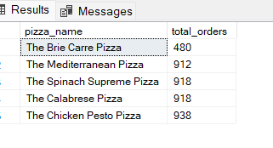

**NOTE:**

**If we want to apply filters we can use where clause to above queries.**